Information and Communications Technologies
Code of Practice

Child/Student
Early Learning and Care – Year 2

Version 6 • December 2020
Document Number: D17/31346[V6]
Date of next Review: 2021
Author: Administration

[
Contents
1. Introduction for Parents 2
2. Definitions 2
3. ICT Code of Practice for Students 3
4. Acceptable Uses 4
5. Unacceptable Uses 4
6. Consequences 4
7. G-Suite for Education – Advice for Parents and Carers 5
Parent/Guardian Letter of Agreement 6

1. Introduction for Parents
The purpose of Information and Communications Technologies (ICT) at St. Joseph’s North Mackay is to:
- enhance student learning opportunities;
- promote student achievement;
- support student – school communication;
The use of ICT within schools/services should be safe, responsible, legal, appropriate and for educational purposes and should follow the guidelines outlined in this Code of Practice.
This ICT Code of Practice applies to the use of all school/service related ICT for educational purposes, whether provided by the school or the student.
Parents/guardians must read and sign this ICT Code of Practice after discussions with their child. It should then be returned to your child’s teacher at St. Joseph’s North Mackay.

2. Definitions
The following words are commonly used within this Code of Practice and are defined as follows to assist you in reading this document:
“Catholic Education” means The Roman Catholic Trust Corporation for the Diocese of Rockhampton trading as Catholic Education Rockhampton. Catholic Education includes the Catholic Education Office Diocese of Rockhampton (CEO), Catholic systemic schools, services and work sites of Catholic Education.
“Student” means persons (children) enrolled within a Catholic Education school/service within the Diocese of Rockhampton.
“Information and Communications Technologies” means any electronic devices or services which allow users to record, send or receive information, in audio, text, image or video form. These devices or services may include but are not restricted to standalone and networked:
- computer systems and related applications such as email and internet;
- social media;
- mobile devices and wearable technologies;
- communication equipment;
- output devices such as printers;
- imaging tools such as video or still cameras;
- audio tools such as audio recording devices;
- software applications and externally provided electronic services.
“Social media” means websites and applications and any other service or device which enable a user to create and share content or to participate in social networking.

3. ICT Code of Practice for Students

At St. Joseph’s North Mackay we have technologies to help us learn.

These may include:

 |  | 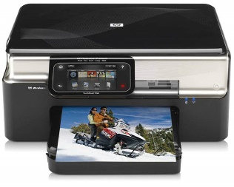
Computer | Laptop | Printer
Internet | Email | Mobile Phone
Camera | Social Media | Coding Robots
 | 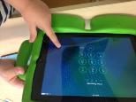
External Hard Drive | iPad | TV/Whiteboard

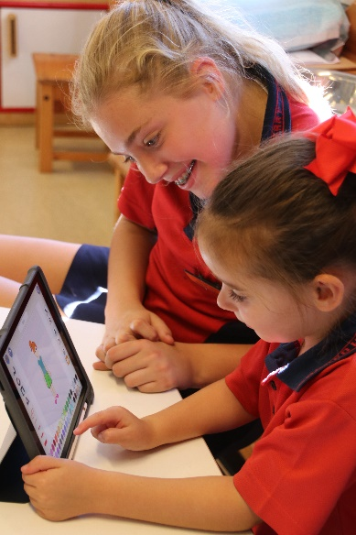
4. Acceptable Uses
When we use technology, I should:

Keep myself safe:
- Keep my password safe.
- Tell my teacher or adult if I see something that makes me feel unsafe.

Respect others:
- Share the technology and wait for my turn.

Respect resources:
- Use the technologies safely.
- Use the files, programs, internet or email as shown by my teacher.
- Take care of the technologies.

5. Unacceptable Uses
I should NOT:
- Say unkind things about other people online.

I should NOT:
- Share my full name, date of birth / age or send my photo using technologies without teacher/adult supervision.
- Bring a wearable technology device to school

I should NOT:
- Use internet social networks, online chats, discussion groups or mailing lists without teacher/adult supervision.

6. Consequences
If I break these rules:
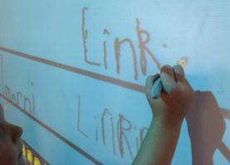
I may not be able to use the technologies.

7. G-Suite for Education – Advice for Parents and Carers
7.1 All students have access to educational collaborative Virtual Learning Environment (VLE), Google G-Suite for Education. This environment provides access to email and a range of collaborative and productivity tools.
7.2 In using the Virtual Learning Environment provided through CEnet and the Rockhampton Catholic Education Diocese, students (with parent permission) consent to the transfer, processing and storage of their data within cloud services.
7.3 The CEnet Agreement with Google and the actions taken by Diocese to establish ICT Codes of Practice will ensure the protection of personal information in accordance with national privacy, data usage, and data security guidelines:
- All advertising is disabled for education users to ensure that there is no tracking of school emails or web browsing.
- All mail is automatically scanned to perform spam filtering, virus detection and to block inappropriate content.
- Authorised staff within Catholic Education will have the ability to access, monitor, and audit emails and associated data as well as internet sites visited for the purposes of managing the system and ensuring its proper use.

Information and Communications Technologies
Code of Practice

Parent/Guardian Letter of Agreement

Parent or Guardian of __________________________________________ (name)

As the parent or guardian, I have read and discussed the ICT Code of Practice with my child. I understand that these ICT resources are designed for educational purposes. I also recognise that it is impossible to completely restrict access to controversial material when using technologies.

I hereby give permission for my child to be given access to information and communication technologies as deemed appropriate by the school. I am also aware that ICT Cloud service providers used by the Diocese may transfer, store and process data outside Australia.

Name: _______________________________ Date: ___________

Signature: ____________________________

NOTE: Failure to sign and return this agreement to your school/service will result in loss of access to ICT.

Please return this section only.

